“Women of Faith” Ministries

Sunday School - Michelle Berlin 586-871-5426
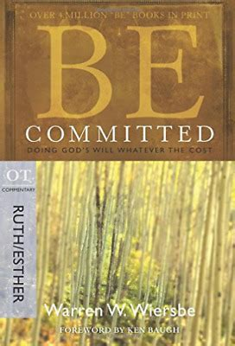
Women of the Word meets in the Ladies’ class each Sunday at 9:45 am. Ruth was a foreigner and peasant. Esther was a reluctant queen married to a stranger. Both showed a remarkable faith committed to doing God’s will. God used stressful circumstances to bring about His eternal purposes. Warren Wiersbe helps you be prepared and "Be Committed: Doing God’s Will Whatever the Cost”.

Bible Studies
Morning Bible Study meets the 2nd Thursday of each month at 11 am in Pastor’s SS class. While the Jews were looking for a king to save them from Rome, God sent us a Savior to save us from our sins. Join us to study Matthew “Be Loyal: Following the King of Kings” by Warren Wiersbe. Carol Katzmarek (586-295-4412) leads us to recognize the glorious, all satisfying King that we serve.

Gretchen Arterberry (574-601-7647) leads the evening Bible study on the last Monday of each month at 7 pm, in the ladies’ class. We are studying “You can trust God to write your story” by Nancy DeMoss Wolgemuth. God is the master Storyteller. He’s writing your story and it’s a part of His bigger, grander, eternal Story. But we’re still in the middle. We haven’t gotten to the happy ending yet, and it can be hard to trust Him in the thick of our struggles.
Come join Millennial Moms (with children newborn through high school) as we search for hope and encouragement from God’s Word and one another. We meet one Monday a month at the home of Sharon Weigle (586-359-9493).

Women of Grace - Widows and Divorcees
Linda Schwartz (810-625-9631) invites you to join her for lunch on the first Sunday of the month for food and fellowship. Please meet at One Stop after the morning service.

Mary Martha Ministry – ALL Single Ladies
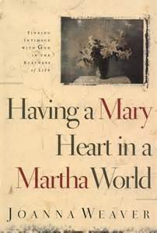
This ministry is specifically designed to encourage and edify others that live alone. Please join Michelle at her home every other month. Martha used her time to serve her Lord faithfully. Mary saw the need to sit at Jesus’ feet even in a busy world. This is an opportunity to reflect on God's goodness and seek His help in our current situation!

Outreach Opportunity – Ladies Night In
All ladies are encouraged to bring a guest to this fun evening! This is an opportunity to introduce a friend to the women of Faith. Join us at church on the 2nd Monday of every other month for games, crafts and more.

Barnabas Group
The homebound would love a visit as they are no longer able to fellowship with the body of Christ regularly. Will you encourage them with Scripture and prayer? To receive a list of potential visits and connect with a visitation partner, please see Diane McKnight (586-610-9647) or Pastor Rob Loach (864-607-5671).

Secret Moms -"Adopt a College Student”
“Secret moms” pray daily for their college student and mail them a card monthly. Secret moms receive prayer requests, needs, and wishes of their college student. Secret moms may enclose a small gift card or care package to brighten their "child's" day. The “mom” is revealed at end of the school year. Each year secret moms are assigned a new college student. Laura Salter (586-215-2405) takes care of the communication with our college students each month as she oversees this ministry.

